National Trends in Surgery for Sinonasal Malignancy: The Effect of Hospital Volume on Short-Term Outcomes

David Ouyang1, Ivan El-Sayed2, Sue S. Yom12

Institutions: 1. Department of Radiation Oncology, University of California, San Francisco, San Francisco, CA, United States, 2. Department of Otolaryngology-Head and Neck Surgery, University of California, San Francisco, San Francisco, CA, United States

Background: Sinonasal carcinomas are rare, highly morbid neoplasms originating in the nasal cavity and paranasal sinuses. The mainstay of treatment over the past two decades has been a combination of surgery, radiation, and chemotherapy. We sought to characterize trends in the initial management of sinonasal malignancy with a particular focus on the impact of hospital volume on surgical care and outcomes.

Methods: A retrospective cohort study was conducted examining time trends among patients admitted for surgical resection of sinonasal malignancy in the National Inpatient Sample (NIS) between 1988 and 2009. Subset analysis of high risk cases was performed on patient cohorts with skull base involvement, orbital or maxillary sinus involvement, or who underwent neck dissection. Patient characteristics as well as hospital attributes were correlated with patient morbidity and mortality.

Results: Over the course of 22 years, we identified 3850 cases of sinonasal surgery patients from 879 hospitals. 24.3% of patients had complications ranging from infections, cardiopulmonary complications, neuropathy, visual disturbances, and electrolyte abnormalities and 0.8% of hospitalizations resulted in mortality. High risk cases with skull base, orbital or maxillary sinus involvement, or including neck dissection had more complications (29.4% vs. 23.2%, p < 0.001) and a longer length of stay (9.34 days vs. 6.13 days, p < 0.001). There was an increase in the number of cases with neck dissection over the time period studied.

Thirty-two hospitals averaged more than 5 cases per year, accounting for 28% (1097) of all sinonasal surgeries. These high-volume centers were predominantly large (73.3%), urban (96.7%), teaching (90%) institutions and performed more high risk cases – accounting for 32.4% of cases including neck dissection, 44.6% of cases with orbital involvement, and 43.1% of cases with skull base involvement. Compared to low-volume centers, high-volume centers had more cardiopulmonary complications (21.1% vs. 17.8%, p = 0.024), electrolyte abnormalities (10.4 vs. 7.2%, p = 0.018), and longer lengths of stay for both high risk cases (10.58 days vs. 8.59 days, p = 0.003) and non-high risk cases (6.84 vs. 5.89, p = 0.004). Over the time period studied, a greater proportion of cases were recently performed at high-volume centers.

Conclusions: This study characterizes current trends in the initial management of sinonasal cancer. There is an increased likelihood that complicated surgeries are performed at higher-volume hospitals which also entails a higher complication rate. High risk cases resulted in higher rates of complications but were not associated with a higher mortality rate.

*Were more high risk surgeries performed over time? In other words, surgical techniques have become more advanced so the number of high risk surgeries might be going up?*

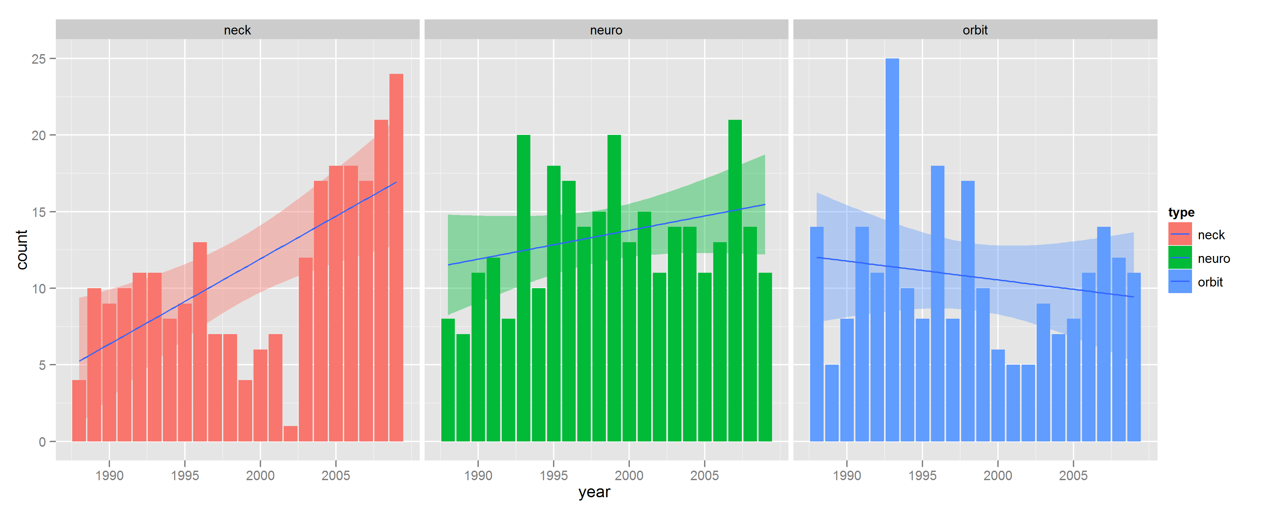

There is a slight trend towards more high risk surgeries in general, however there is a more significant trend of neck dissection.

*Among high risk surgeries that were performed, what was the complication rate for low volume, intermediate volume, and high volume hospitals? Is there any way to find out whether these complications were minor or severe?*

Complication rate was generally similar, no time trend.

*What was the average hospital stay for high risk cases versus lower risk cases? For high volume versus low or intermediate volume hospitals?*

Average LOS for high volume centers was 7.29 days, with high risk cohort being 9.73 days.

Average LOS for low volume center was 6.72 days, with high risk cohort being 9.34 days.

difference on overall LOS: high: 7.79 vs. low: 6.31 (p < 0.001)

LOS (high risk + high volume): 10.58, LOS (high risk + high volume): 8.59, p = 0.003

LOS (low risk + high volume): 6.84, LOS (low risk + high volume): 5.89, p = 0.004